# **New Idea**

The new ideas being proposed will take the research done in the previous section into consideration and will try to integrate the strong points as well as improve on the areas where the current solutions lacked. The proposed solution is a smartphone application which encourages individuals to live a healthier lifestyle. The reason for this is because in today’s modern age, every kid, teenager and adult have a smartphone, so the proposed solution would be able to reach a wider audience compared to a smartwatch or a website. The main target audience the proposed application will focus on will be individuals below 40 years old, however this does not mean users aged +40 years old will not be able to use the application or gain its benefits.

**Application Features**

**Registration and BMI Test**

When the users first use the application, they will be required to signup/register before they can start using the application. After successfully registering, they will be asked few very simple questions to help determine if they are healthy, overweight, or underweight (BMI test). In addition to this this, they will be asked what their end goal is; whether it is to lose weight, gain weight or to maintain their weight. The application will then recommend the user how much calories they should burn each day and what their calories intake should be, to successfully maintain/reduce or gain weight at a healthy pace; it will also recommend a physical activity/exercise or sports which can help the user burn the right amounts of calories and the types of beneficial food (i.e. Carbs if trying to gain weight).

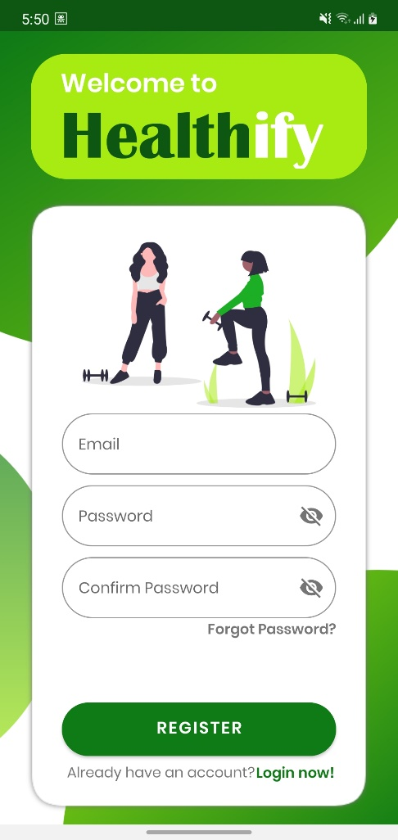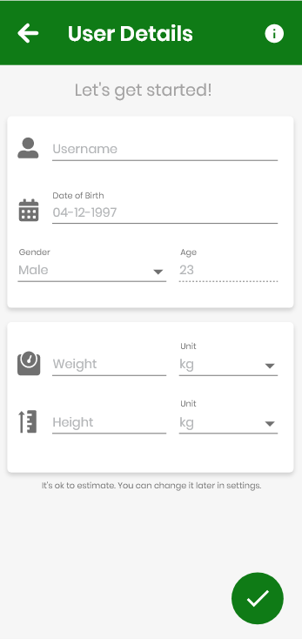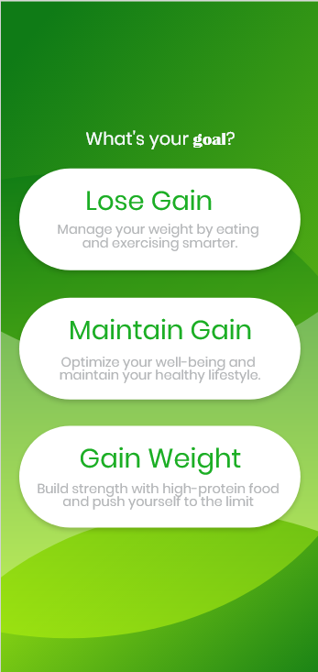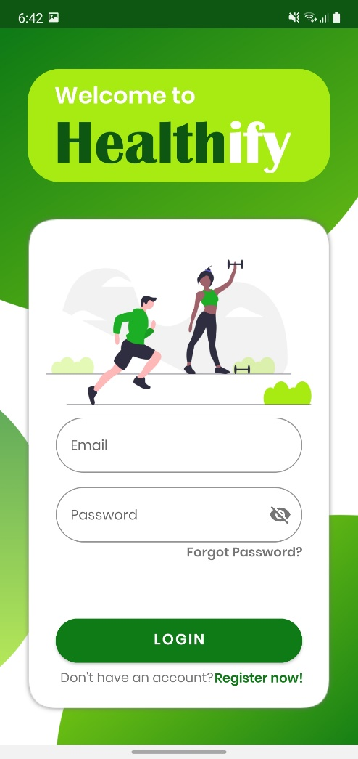

**Track Progress**

The users will also be able to log their daily physical activity through the proposed application. This will allow the application to track users’ progress/statistics and present them in forms of graphs or charts. Using this data, the app will give the user a visual representation of their progress, how much they have improved and how far they are to reach their goals. It will also allow the user to display their progress weekly or monthly, in addition, show a comparison graph of their progress from the previous week/month.

**Sport & Exercise Encyclopaedia**

The proposed application will have information regarding all sports to help promote exercise by giving helpful tips and advice. It will have a brief description of the sports and explain the benefits each sport will have on the body, how many calories players could burn on average, equipment you will require in-order to begin and the general costs you may need to think about (i.e. club membership etc). The application will also allow players to search for any local clubs or sport centres/facilities in their local arena or within a certain radius doing that sport. It will then display all the local clubs/facilities with the chosen radius, their address, contact information, and furthermore their location pinned on the map. This will be possible after the user provides the application their post code, which the application will use to filter the data and display the correct facilities. Aside from sport activities, the app will also contain other form of physical activities for those not interested in sports; for example, Hiking, Yoga and Running etc. In addition to all this, it will also recommend other applications dedicated to a certain sport or physical activity for those users who don’t wish to join a club or go the facility due to busy schedules etc. For example, if a user wanted to do yoga, but didn’t wish to join a yoga club and wanted to do it at home, the proposed application will recommend the user some external application such as ‘Glo’ which is a mobile application dedicated to yoga and allows the user to practice at home. There will also be diagrams/illustrations provided for each exercise that can be performed at home, so the user’s do not injure themselves performing it incorrectly.

**Daily Challenges**

The proposed application will provide users daily challenges to help keep them motivated, which will earn them points when they complete them. At the end of each week, using the points, the users will be ranked depending on how many challenges they have completed. This will provide a competitive aspect which will motivate users more as they would want to be ranked higher than others allowing them to push themselves to gain as much points as they can weekly, resulting in them doing more exercise and staying healthy.

**Chat Room and My Story**

The application will also include a chat feature to keep users engaged where they are able to talk to fellow users about their experience and help others or to gain advice. Interaction with other people will help users stay motivated to keep pushing themselves to reach their goals as they know they aren’t alone. In addition to this, there will be a blog type feature called “My Story” where users can share their success stories, their progress thus far or any helpful advice they would like to give new users.

**Sleep Tracker**

There will also be a “Sleep Tracker” feature which will help users manage their sleeping schedule; not having enough sleep can affect their motivation because if they are tired then they will most likely not want to exercise. According to NHS, “people who sleep less than 7 hours a day tend to gain more weight and have a higher risk of becoming obese”, therefore having the right amount of sleep can be very important to an individual’s health (NHS, 2018).

**Water Intake Tracker**

In addition to the sleep tracking function, there will also be a feature within the application which helps keep track of how much water they are consuming, as being hydrated is very important for exercising and a healthier lifestyle. The user will be sent a notification at every set interval to remind them to take a water break so they can consume the minimum amount of water the body needs. In a recent study, one of the negative impacts drinking less water will have on your body is amongst countless others, is weight gain (Henry Ford, 2020).

# **Project Requirements**

This section will detail the overall project requirements and resources needed for developing the proposed solution. It will also list the requirements that should be met in order for the proposed project to be considered a success.

## **Resources**

The table below (Table 2) shows a list of general resources required for the project, as well as any additional requirements.

**Table 2: Required Resources for the Project**

|  |  |  |
| --- | --- | --- |
| **Software** | **Hardware** | **Other** |
| Android Studio IDE, Adobe Xd | Smartphone with Android 4.3+ operating system | Android Developers Documentation, Material Design Documentation, YouTube, Java and XML Docs |
| Firebase Realtime Database |  | Firebase Documentation, Google Account |
| GitHub Desktop |  | GitHub VCS Repository, GitHub Account |

A software development environment is required for the app to be developed in and Android Studio is currently one of the best Integrated Development Environment (IDE) for developing android applications (Alex mullis, 2020). Adobe Xd will be used to design the proposed application which will make things easier when developing it. A smartphone with android operating system with the minimum version of jellybean (4.3) will be required to run the proposed application; older versions will not be able to support some of the application features. To aid the development process, the android developers and material design documentation (alongside others) will be used to help utilise and implement some of the proposed features successfully.

Firebase Realtime Database will be used to store all the user and the application data. Firebase Realtime Database updates information and provides the latest data in-real time thus the application will always be up to date with the latest data. Firebase documentations will be used to make sure that the firebase database is implemented successfully and works as intended. However, in order to use firebase database, a google account will be required.

A version control system repository will be required to store different version of the project’s source code. This will allow to rollback to an older version of the source code if the application breaks due to bugs or errors in the code which cannot be identified. Using the software ‘GitHub Desktop’ will make it easier to keep track of the changes made to the code as it provides the changes and the differences in the code visually, in addition to adding small comments or notes before you commit to the repository.

## **Software Requirements**

All the functional and non-functional requirements for the proposed application are listed below

**Functional requirements**

The application must:

**FR1** – allow multiple user accounts.

**FR2** – allow the user to register.

**FR3** – allow users to sign in their accounts

**FR4** – allow users to sign out

**FR5** – store the user data in the cloud database

**FR6** – allow users to update their personal information (password, username etc.)

**FR7** – work out the users’ BMI test results using the data provided

**FR8** – show what their (healthy) weight should be

**FR9** – show what their daily calory intake should be

**FR10** – recommend the best exercise/sport to help them with their end goal

**FR11** – recommend the types of food which will help with their end goal

**FR12** – allow users to log their daily physical activity

**FR13** – keep track of users’ progress

**FR14** – display a graph to show their progress (weekly/monthly)

**FR15** – display information on any local clubs/facilities in the users’ area

**FR16** – display information on all sports

**FR17** – display indoor physical activities

**FR18** – display diagrams on how to perform certain exercises correctly

**FR19** – recommend external applications which specialises on areas the proposed application lacks on

**FR20** – provide new daily challenges

**FR21** – display users on a table, ranked depending on how many challenges they complete

**FR22** – allow users to join the “chat room”

**FR23** – allow users to send messages to each other in the chat room

**FR24** – allow users to post their motivational stories

**FR25** – allow users to see other users’ motivational stories

**FR26** – allow users to log their sleeping schedule

**FR28** – display if user is getting enough sleep

**FR29** – track amount of users’ water intake

**FR30** – send notification every set interval to remind user to drink water

**FR31** – work out how many calories they burned during the week

**FR32** – display a graph to show if they are on target/of target from their initial goal

**FR33** – The application features will not be available if the user is not signed in

## **Non-functional**

Non-functional requirements

**NFR1** – the design and layout of the proposed app should be user-friendly and professional

**NFR2** – the application should be easy to navigate through

**NFR3** – the colour theme should be appropriate for the target audience and should correspond, in addition to convey the message of the ‘health’ aspect of the proposed application

**NFR4** – use appropriate font that is easy and clear to read

**NFR5** - the colour scheme and the typography should be consistent throughout the whole app

**NFR6** – all types of android phones with the 4.3 operating system (or above) should be able to use the proposed application

**Justification of Requirements**

The software requirements listed above were decided based on the information gathered as part of the primary research and researching the existing solutions available.

Allowing users to create their own accounts are necessary in order to distinguish individual users and storing their data separately. Personalised accounts will help users identify each other more easily and help the application keep track as well as retrieve correct data for each user.

Storing the data in a cloud database will make sure the data is safe and can be accessed remotely, therefore the users can use the application on different phones and they will not lose their progress. This will also ensure users do not have access to other people’s personal information and is kept safe.

Getting the users’ BMI results are important because this will allow the application to help the users better by providing the necessary information they will need to reach their long term goal.

Having a visual representation of their progress will keep them motivated as they will be able to visually see the progress they are making over the course of the month. By providing competitive aspect where there will be a table of users who have completed most daily challenges set by the app, will allow users to push themselves further and help them stay motivated to reach their goal.

Allowing user interaction through “chat rooms” and “My Story” feature will allow them to keep each other motivated by sharing their success stories or by guiding others who are new to the application and need some advice.

# **Project Schedule**

The following section contains the planned project schedule outlining the estimation of workload for various phases and the tasks to be completed for the respective phase.

## **Project objective and milestones**

The projects main objectives and milestones are as follows:

* Research and review existing solutions
* Identity the limitations of the current solutions
* Create a prototype of the proposed solution
* Implement the proposed solution
* Test and evaluate the implemented solution

Table 3 represents the project milestones with the deliverables required for each milestone

**Table 3: Project Milestones**

|  |  |
| --- | --- |
| **Milestone** | **Deliverables** |
| Project Registration | Project Proposal  Project approval |
| Review Point 1 | Project Monitoring Form RP1  Project Planning Document  Ethical Issues Declaration Form |
| Review Point 2 | Project Monitoring Form RP2  First Draft of Context Chapter  Discussion on Next Draft – New Ideas Chapter |
| Review Point 3 | Project Monitoring Form RP3  First Draft of New Ideas Chapter  Discussion on Project Implementation  Discussion on Next Draft - Project Implementation Chapter |
| Project Submission | Project Report  Implementation Report |
| Demonstration (FYP Degree Showcase) | Implemented Solution |

# Project Gantt chart

**Figure 5: Gantt Chart**

# **References**

Nhs. 2018. Why lack of sleep is bad for your health. [Online]. [24 February 2021]. Available from: https://www.nhs.uk/live-well/sleep-and-tiredness/why-lack-of-sleep-is-bad-for-your-health/

Henry ford health system. 2020. 6 Side Effects Of Not Drinking Enough Water. [Online]. [24 February 2021]. Available from: https://www.henryford.com/blog/2020/05/side-effects-of-not-drinking-water

Alex mullis. 2020. The best Android developer tools for getting started. [Online]. [24 February 2021]. Available from: https://www.androidauthority.com/best-android-developer-tools-671650/